

Deployment Guide for e-SMP
Version: 04b

Revision History
Date | Version | Description | Author
31/1/2012 | 01 | Create new deployment guide for e-SMP | dttanh
12/12/2012 | 02 | Added configuration + installation of decentralized mode | dttanh
19/12/2012 | 03 | Added part 2.4 Extra directories | dttanh
20/02/2015 | 04 | Fully reviewed deployment guide  - Added new SQL server deployment part  - Added new troubleshooting part  - Restructuring for better comprehension (sub-sections)  - Several corrections in different parts | T. Mayer
20/02/2015 | 04a | Added a missing figure | T. Mayer
05/11/2015 | 04b | Corrections of SQL connection paragraph | T. Mayer

Table of Contents
Revision History 2
Table of Contents 3
Preface 4

1 Prerequisites 5

2 Deployment Guide 6
2.1 Set up of Microsoft SQL Server 6
2.2 Set up of Microsoft IIS (Internet Information Service) 11
2.3 Compile e-SMP and publish it to IIS 15
2.4 e-SMP Server Troubelshooting 19

3 Configuration Options 21
3.1 Extra directories 22
3.1.1 InterviewDirectoryName 22
3.1.2 InterviewExportDirectoryName 22
3.1.3 ExportDatabaseDirectoryName 22
3.1.4 OnlineHelpPath 22
3.1.5 PhotoDirectory 23
3.2 Installation of Decentralized Mode 23

Preface
This document describes how to deploy a full e-SMP server environment. This consists of two parts, an Mircosoft SQL server for data storage and an Internet Information Server (IIS). After the deployment, the compilation and publishing to e-SMP will outlined, which followed by some additional information (configuration options, decentralized mode).
This deployment guide does not explain the operating system installation; it is assumed to be available (Windows Server 2008 R2) will all updates and service packs.

SECURITY WARNING
This document reveals some standard passwords (e.g. for SQL server).

IMPORTANT
Concurrent to this document (in v4), a ready-to-use Virtualbox virtual machine (VM) has been created. However, it uses private MSDNAA licenses (of Tobias Mayer) for the SQL server and Visual Studio, while Windows Server is not yet activated. For individual deployments of this VO, use the “Apply individual licences for virtualbox VM utilization” guide in order to use own licenses.
TO BE ADDED: guide how to change licenses
A utilization of the virtual machine requires an individual license of the following software. Currently private MSDNAA licenses of Tobias Mayer are used.
- Microsoft SQL Server
- Visual Studio Professional
- Windows Server 2008 R2 (not yet activated)

- Prerequisites
The major software used for this guide is the following. Note the installation may has further dependencies and requires additional software.
- Window server 2008 R8
- Sql Server 2008 R2 – (from 10.50.xxxx)
Theoretically, a higher version (e.g. 2012) could be used. However, Microsoft does not support the migragration of the DB to SQL server with lower versions (e.g. from 2012 to 2008). In addition, technical incompabilities are possible due to server evolution (not tested).
- Microsoft SQL Studio Management
- Microsoft IIS
- .NetFrameWork 4.0
- Silverlight 5
Consists of Silverlight 5 itself for the server, the Silverlight SDK and Silverlight Tools (requires also Visual Web Developer feature for Visual Studio SP1).
Note that it is available for free (in addition to the express version) for research institutions through the MSDNAA program (also Visual Studio Professional, Windows Server versions). Check the eligibility.
- Deployment Guide
The following guideline illustrates how to set up an e-SMP server with SQL and IIS at the same machine. This is recommended as development/test environment. For productive use the installation should be done on separated machines.
- Set up of Microsoft SQL Server
Step 1: SQL Server installation – download & install SQL Server 2008 R2
Install the SQL server with the functions as shown in the figure below. Make sure that
- “Management Tools – Complete” is checked (to install SQL Studio Management)
- “Database Engine Services” is checked (to create a DB instance during setup)
The other functionalities are a proposal and not necessarily needed.
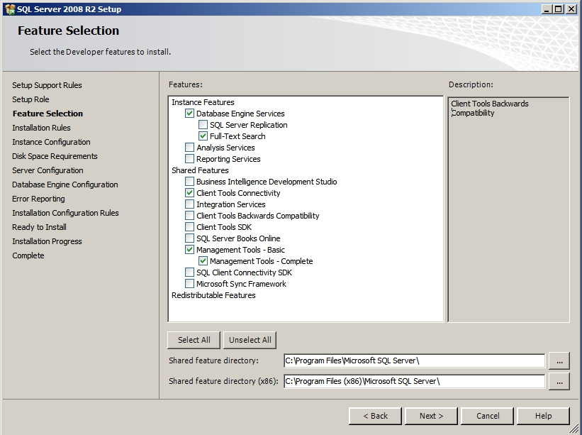

Step 2: SQL Server installation – create DB instance
After feature installation, create a DB installation through the installation dialog. Rename the ID to “ESMP” (or whatever preferred name) and check the DB root directory.

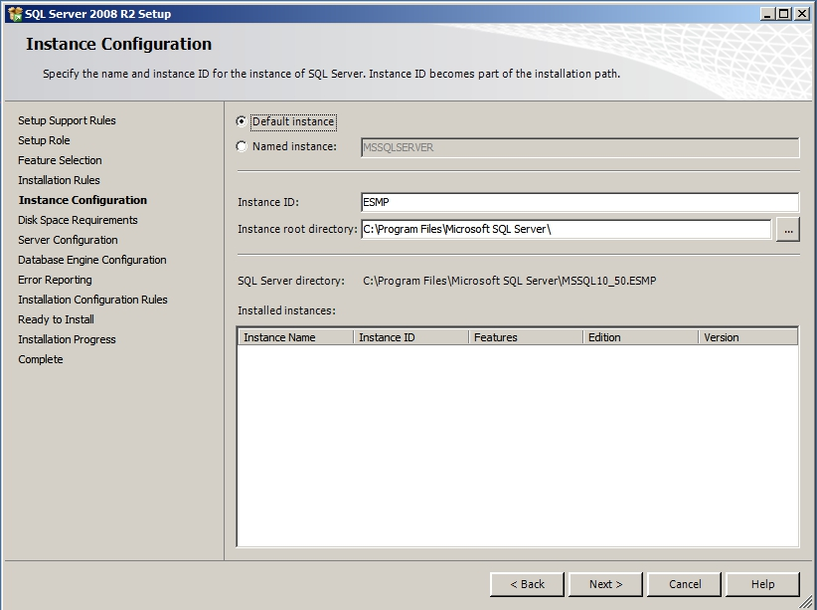
Step 3: SQL Server installation – set service accounts
Specify accounts for the SQL services. In the figure, the local administrator is used. Feel free to create dedicated users.
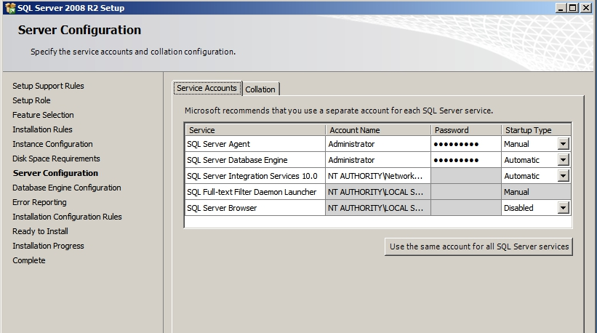

Step 4: SQL Server installation – configure DB engine
Set the DB to mixed mode with an appropriate password (here: esmp_admin111). This allows to login as windows (Administrator) and as SQL user that are maintained inside the SQL server.
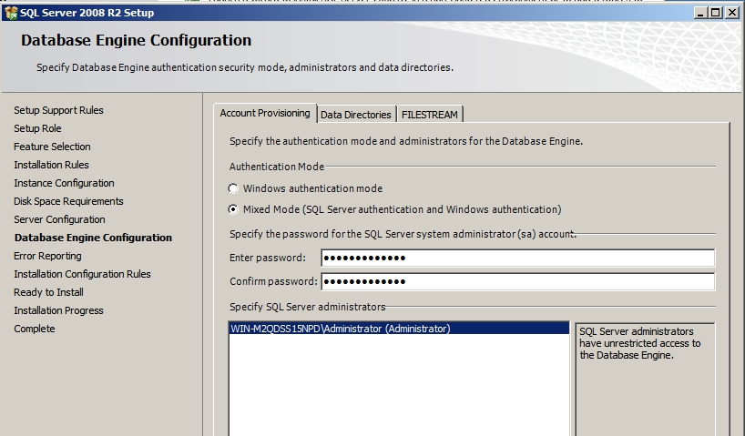
Step 4: First logon and create SQL user
Start the SQL studio management and logon with the Windows system user account Administrator
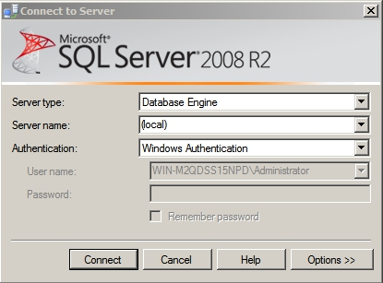
Then, create a new user esmp, here also with the password esmp (a secure password should be chosen here), deactivate “Enforce password policy” (to avoid forcing of password changes etc.). Assign the user then to all Server Roles to make him an administrator.
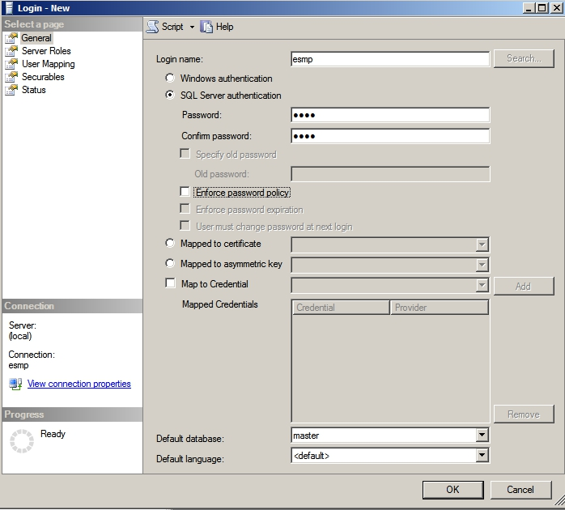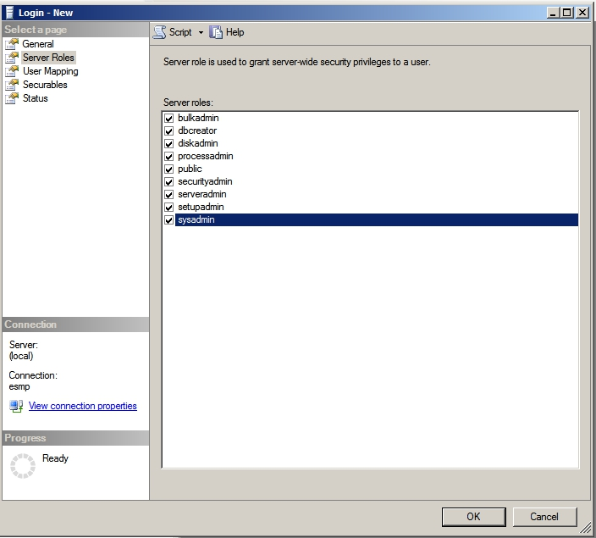

Step 4: Restore databases with e-SMP test data
Step 4.1 Get DBs The following steps import databases with test data that can be used for developments. At first, get a backup of existing DBs. For example, go to the filedepot ftp server and get the latest DB version (esmp_im.bak and esmp_sc.bak).
Step 4.2 Logon as esmp user created before Logon with the SQL Studio Management as the esmp user created before. NOTE that this user and connection type (e.g. database engine with “(local)”) will be used later for the DB connection of the published e-SMP.
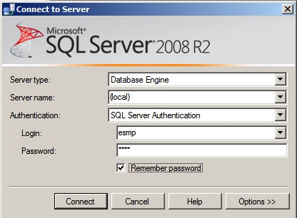
Step 4.3 Restore DBs Right-click on databases and choose “restore database” and import esmp_im as shown in the figure below. Do the same afterwards with esmp_sc.
Step 4.4 Set user mapping Go to properties and assign the user esmp to all databases (see figure), particularly the new important ones.
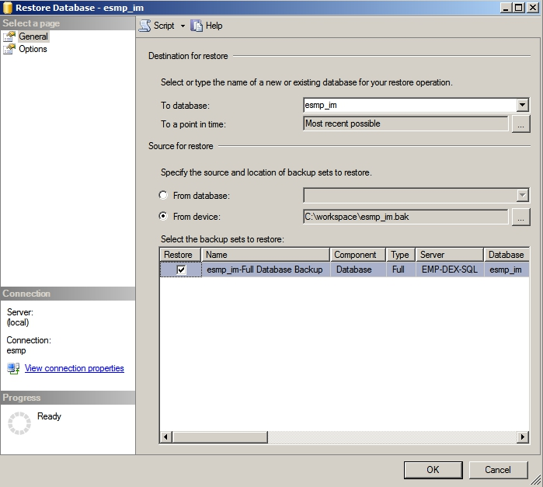
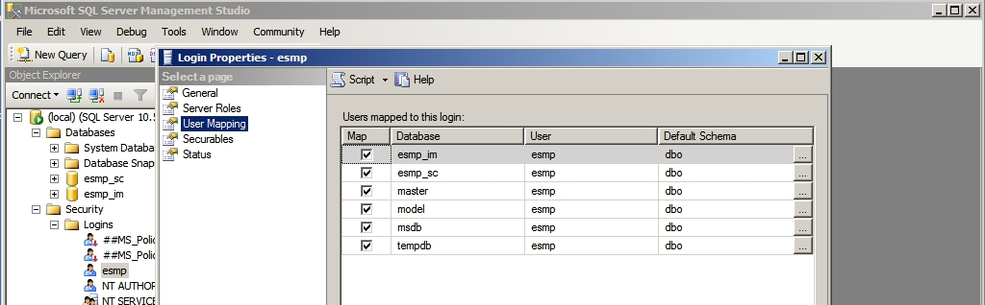
Now the database is set up (with restored test data) and ready to be accessed by the e-SMP applications through the Microsoft IIS.

- Set up of Microsoft IIS (Internet Information Service)
Step 1: Install IIS and its server role features
Under Windows 2008 R2 select in the server manager the “roles” section and add new roles. In the wizard, select the Web Sever (IIS) with the featrues as shown in the figures below.
Note: In other systems such as Windows 7 the installation is slightly different, e.g. the installation is done over Start\Settings\Control Panel\Programs\Programs and Functions\Activate or deactive Windows Functions.

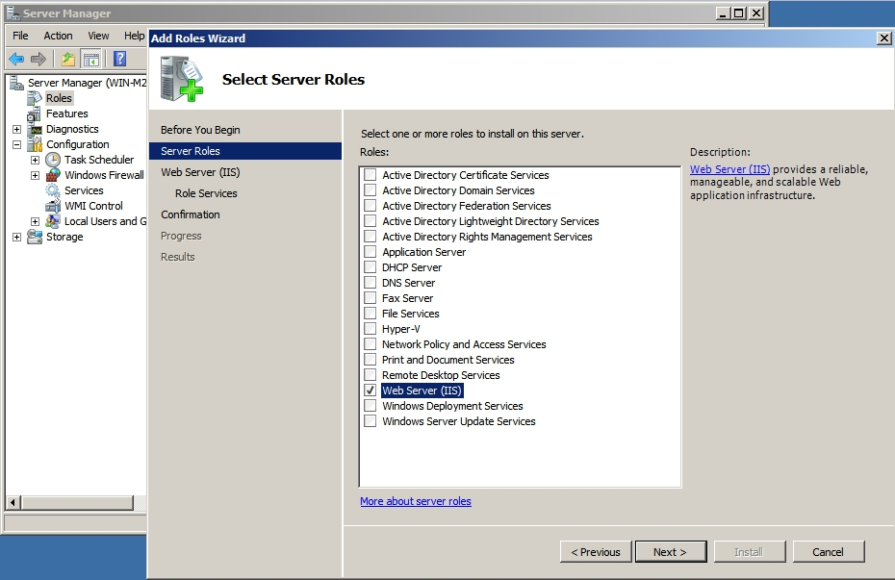
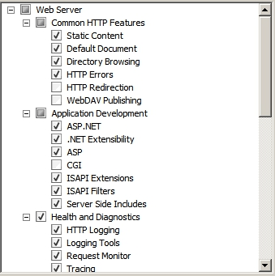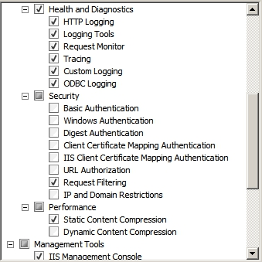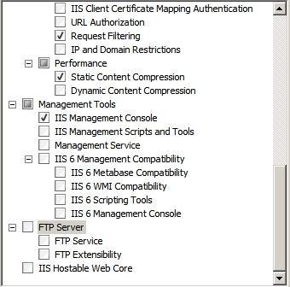
Step 2: Create application pool
Open the IIS manager for configuration by opening it through the “Server Manager” or through
“Start\Setting\ Control Panel\Administrative Tools\ Internet Information Services (IIS) Manager”.

To create an new applicaton pool dialog
- right-clicking on Application Pools Add Application Pool …
- Assign the name “esmp” (or an individual one) and choose .NET Framework v4

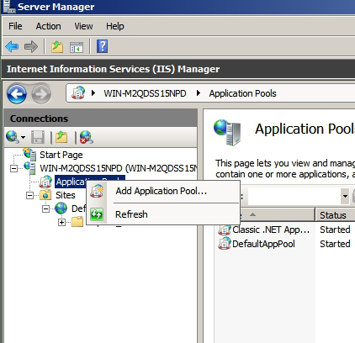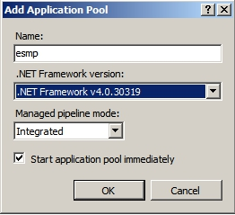

Step 3: Add an IIS application

Right Click on “Default Web Site” Add Application

In the dialog:
- Set “esmp” as “Alias”
- Set “esmp” as Application Pool (the one that has just been created)
- Create a website root directory and indicate as physical path

Now, the dialogue should look as the following figure.
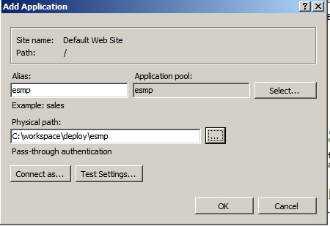

Click Ok to continue. Now, you can see application “emp” on IIS.
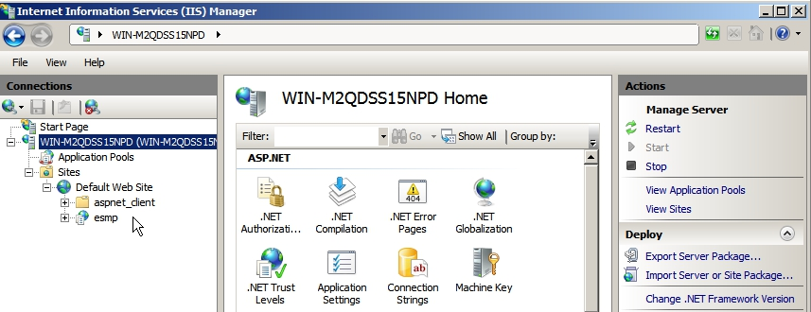

Step 4: Set permission on folder of deployment
Open the permissions configuration of the esmp website by
- right-click on the “esmp” folder under “Default Web Sites”
- “Edit permission” option to open the Properties dialog and choose the “Security” tab

Set appropriate permissions by
- Select “Users” group and edit them (click on edit button)
- Select “write” permissions (and possibly others) to enable read&write permissions as shown in the figure.

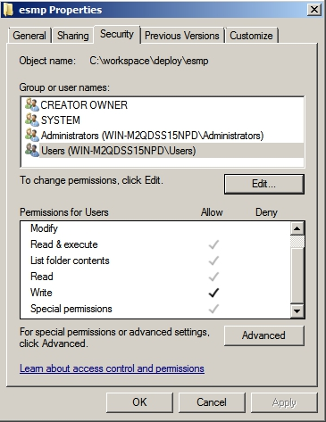

That’s it. The Microsoft IIS is ready to be used by a publishment through Visual Studio.
- Compile e-SMP and publish it to IIS with SQL connection

Step 1: Install required software
Step 1.1 Software installation To compile e-SMP, install Visual Studio 2010 Profession (not “Express”; higher versions such as 2103 have not been tested) with at least the functionalities shown in the figure. Make sure to install the “Visual Web Developer”, “Visual C#” and (for GloboDiet GUI) “Visual Basic”.
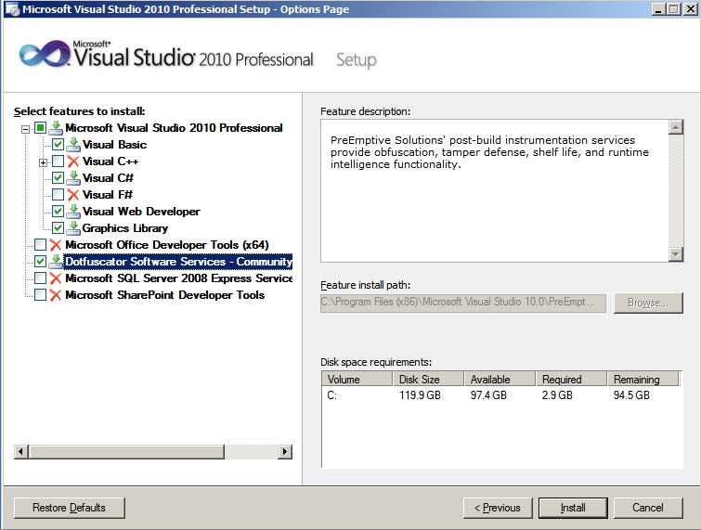
Step 1.2 Install Visual Studio SP1 Install also the Visual Studio 2010 Service Pack 1 (SP1).
Step 1.3 Install the Silverlight 5 SDK This is needed for the e-SMP user interface compilation.
Step 1.4 Install the Silverlight 5 Tools for Visual Studio SP1 This is a Silverlight update for the SP1 of Visual Studio.
Step 1.5 System update (optional but recommended) Bring the whole system up-to-date with the Windows Update Service to install lates bugfixes and security patches

Step 2: Compile the e-SMP system (with SQL connection parameters)

Step 2.1 Get e-SMP sources
- Install Tortoise SVN as client for subversion servers.
- Create at your favorite place a directory “svn” (or you preferred name).
- Right-click on the svn folder and select “svn check-out …” to download a working copy into the folder with the name “svn” (this fills-out the “Checkout directory” field).
- Enter “https://193.51.164.134/svn/esmp/” as URL of repository (this is the svn server of DEX)

Click ok to start the checkout process. You need to have a valid svn login.

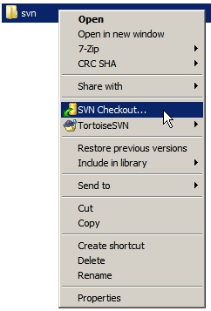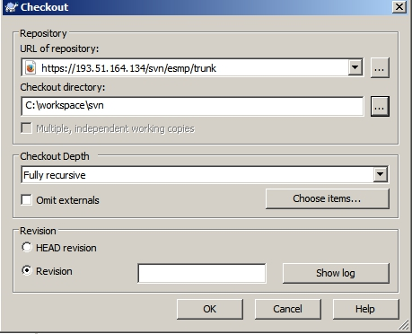

NOTE: The source code to be used may differ from the latest version of trunk. For example, the latest stable one is Revision 223 with IMapp version 2.3.2. Also branches may have be created. Ask your current contact person which version to use.

Step 2.2 Open Visual Studio project file and compile project
- Start Visual Studio application
- Open the e-SMP project file (the so-called “solution file”) “EMP.sln”. Relative to the svn root directory (here C:\workspace\svn), it is stored in “svn-root\Source\ESMP\EMP.sln”
- Verify that the folders “EMPClient” and “EMPClient.Web” exist in the “Solution Explorer” on the right side of the Visual Studio interface (see figure). If not, there are probably problems with the Silverlight SDK / plugin.
- Right-click on “Solution ‘EMP’” and click on “Clean Solution” and then on “Rebuild Solution”.
If you get the message “========= Rebuild All: 18 succeeded, 0 failed, 0 skipped =========”, then you are ready to publish the compiled e-SMP to the IIS.

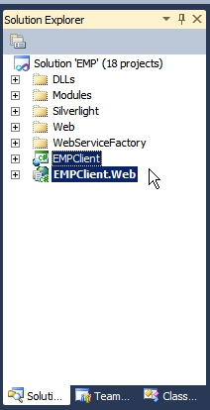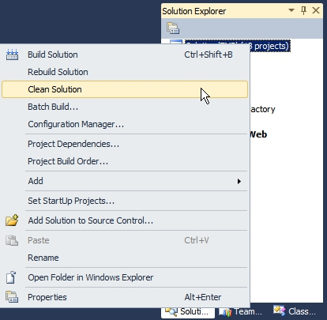

Step 3: Configure SQL connection and publish the compiled e-SMP system to the web server

Step 3.1 Configure SQL connection to local or remote SQL server
Open the “Web.config” in “EMPClient.Web” project (see figure below), and change the SQL: Modify the following fields for “Initial Catalog=emp_im” and “Initial Catalog=emp_sc” (the two databases we restored before in the SQL guideline).
- “Data Source=” set the URL or IP address of the SQL server with the application alias defined before. Here (since it is local), use “Data Source=(local)”
- “User ID=” the SQL user id, i.e. “esmp”
- “Password=” the SQL user password, i.e. “esmp” too (you should use better passwords)

Note: Enter the values that you also used with the SQL Management Studio, i.e. “(local)” for database, with user/password (esmp/esmp).

IMPORTANT: These information must be modified if you change the SQL server (e.g. shift from local to remote SQL server).

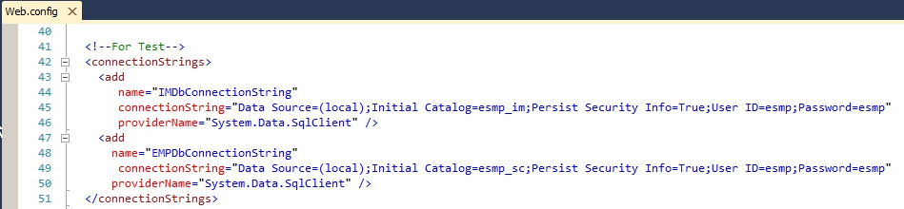

Step 3.2 Rebuild the solution

Step 3.3 Publish the solution
- After the compilation finished Publish it in deployed folder: Right click on “EMPClient.Web” project Publish
- In the popup dialog, choose “File System” as publishing method and choose the IIS deployment directory “C:\workspace\deploy\esmp” (see also IIS guide).

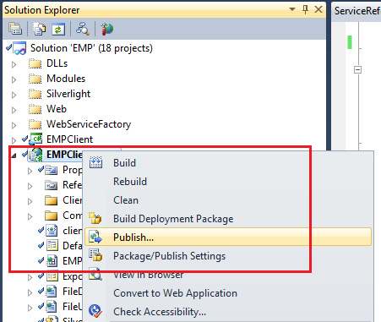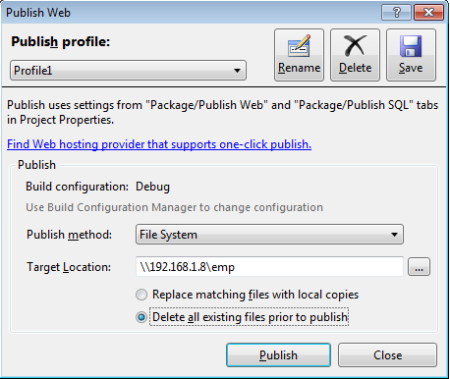

Notes:
- We chose the local folder since the web server and the development environment are on the same machine. If not, use corresponding deploy methods (e.g. Web Deploy, ftp).
- After compiling, you can also manually deploying the solution by going to “ClientBin” folder of “EMPClient.Web” and copy all its contents to IIS folder used for e-SMP.

Finished! Your e-SMP server should work now under the URL http://localhost/esmp.

Don’t forget to install the Silverlight browser plugin for testing. Use “admin” and “admDEX2012” to log in.

- e-SMP Server Troubelshooting

Problem: HTTP Error 500.21 – Internal Server Error
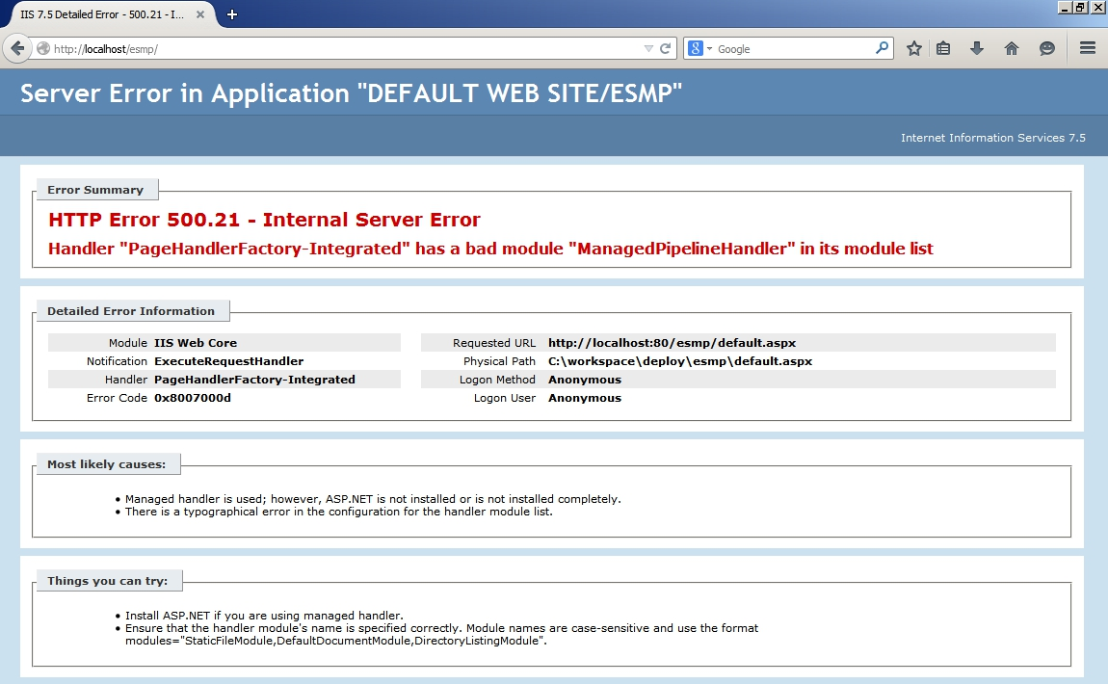

Solution: The ASP.NET compenents must be registered for the Microsoft IIS
- Open the command line (StartRun…cmd.exe)
- Go to the folder where aspnet_regiis.exe is stored. Here, it is C:\Windows\Microsoft.NET\Framework\v4.0.30319. So type cd (change directory) and the path
- Execute the “aspnet_regiis.exe” with argument “-i”

The problem should be fixed now. To be secure, clean, rebuild, re-publish the solution and restart the IIS.

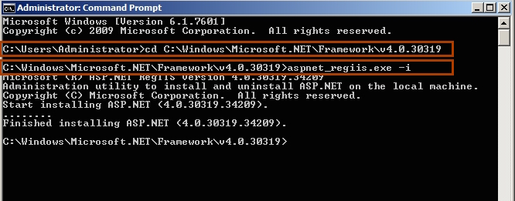

Problem:e-SMP screen is shown but not text; login does not work

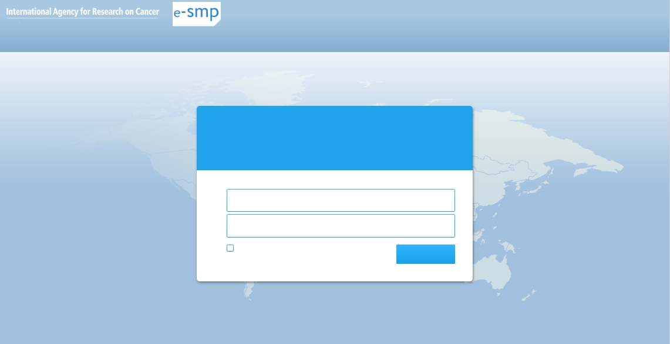

Reason: A connection to the database cannot be established

Solution: Correct the credentials for data source connection
- Open the file “Web.config” in Visual Studio
- Check in the tag “<connectionsStrings>” the values
  - Data source
  - Initial Catalog
  - User ID
  - Password
- Do this for both databases (esmp_im and esmp_sc)

Note: They should have the values as you use to connect with SQL Management Studio). See also publishing 3.1 for a screenshot of a running entry that corresponds to the values of this guideline.
- Configuration Options
The following configurations are defined in web.config

Config | Values | Description
AdminMode | True, False | Used in development, if the Admin mode = true, system will display all available screens without checking permission  In Production, this config should be "False"
DecentralizedMode | True, False | Indicate that IM is in "Centralized Mode" (False) or "Decentralized Mode" (True):
LocalResources | True, False | Used in development, If True Resource Texts will be loaded from xml files; otherwise they will be loaded from database.  In Production, this Config should be "False"
HideException | True, False | Used in development or test to find the error easily (Detail error message, exception). But in production, the message isn't friendly to user so this param should be "True".
CheckControl | True, False | To synchronize IM with MS database the MS database will need to be controlled without error, but MS is still in development, this will be very hard action.  Set CheckControl = "False" will ignore this step, User will have to know if data is good or not  This is temporary parameter to run IM without complete MS
IsDefaultLanguage | True, False | Config in development, keep as "True" in Production
IdMainLanguage | 55 | Configuration for main language (en-GB). Please keep this value in development
MainLanguageCultureCode | en-GB | Configuration for main language (en-GB). Please keep this value in development
InterviewDirectoryName | ITV | Relative Path of Folder to store Interview File used for uploading (Root Folder is "Deployed Folder)
InterviewExportDirectoryName | Export | Relative Path of Folder to store Interview File used for Exporting (Root Folder is InterviewDirectoryName)
ExportDatabaseDirectoryName | ExportDatabase | Relative Path of Folder to store exported EpicsoftDatabase (Root Folder is "Deployed Folder)
StartUpScreen |  | Used in Development Keep it as "Empty" for Production
DeployedPath | http://193.51.164.133/ | It's your link of e-SMP, it'll be used for alert
OnlineHelpPath | \\OnlineHelp\\ | Relative Path of Folder to store Online Help (Root Folder is "Deployed Folder)
PhotoDirectory |  | Relative Path of Folder to store Image (Root Folder is "Deployed Folder)
SC_Version |  | Version of SC
IM_Version |  | Version of IM
MS_Version |  | Version of MS
- Extra directories
- InterviewDirectoryName
This folder is used to store Interview files uploaded by user in IM.
Permission needed for e-SMP: read – write.
- InterviewExportDirectoryName
This folder is inside the "InterviewDirectoryName" which is used to store interviews files (xml, csv) that exported by IM.
Permission needed for e-SMP: read - write
- ExportDatabaseDirectoryName
This folder is used to store "Expicsoft database (xml)" + IM Parameters exported by MS
Permission needed for e-SMP: read – write.
- OnlineHelpPath
In this figure: "ESMP", "Projects", "Project_" are static name
The help files for each perimeter (Project data or country data) are stored in the corresponding folder as marked
Permission needed for e-SMP: read - write
- PhotoDirectory
This folder is used to store Photo for MS (Photo Serie, Shape, Thickness, HHM and Epictext).
Permission needed for e-SMP: read – write
- Installation of Decentralized Mode
To deploy e-SMP in decentralized Mode:
- Step 1: Prepare SC, IM database for decentralized deployment:
This should be done by Administrator of CIRC's server:
- Clone SC, IM database from central servers to 2 new databases: esmp_sc_empty & esmp_im_empty for example
- For IM: Run the StoreProcedure "ClearIMDatabase" to clear all data
- For SC: Open the project screen (e-SMP at central server) to export a script:
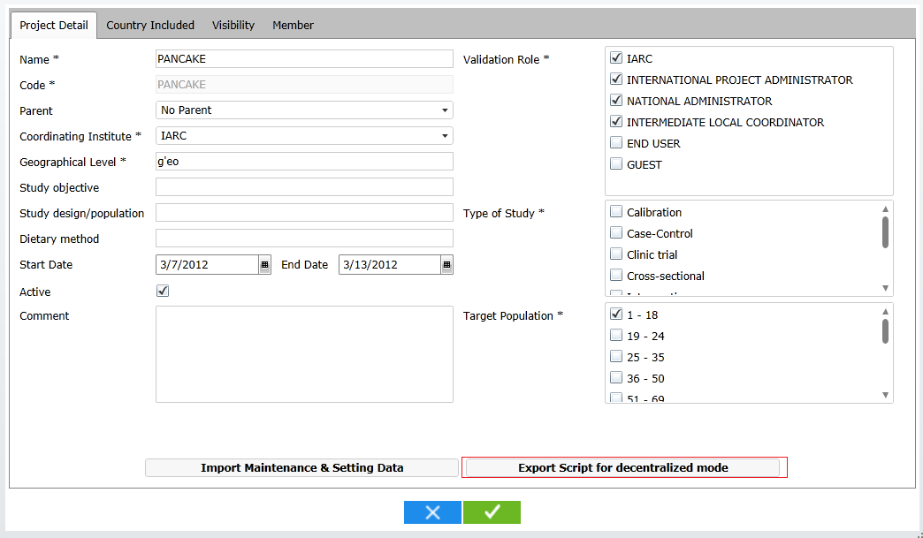
Click on "Export Script for decentralized Mode:
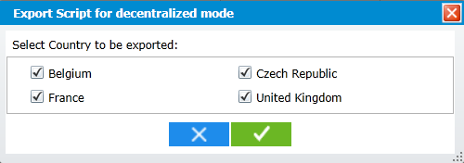
Choose the country and click on OK button, you'll get a script for SC database
Run this script on the cloned SC database (esmp_sc_empty)
Which script? Where is it located?
[Iteal]: Script that is generated by this export. When the user validates this popup (click on ) a script is generated and a popup allowing to download it is displayed.

Now you'll have 2 database IM & SC which are for decentralized mode. Backup them to 2 backup files to restore in decentralized server:
- esmp_sc_empty.bak
- emsp_im_empty.bak

- Step 2:
Restore the 2 database created in step 1 to decentralized server.

- Step 3:
Deploy e-SMP with DecentralizedMode = True in web.config at decentralized server.

- Step 4:
Now the decentralized server is ready to use but no IM Parameter. You'll need to import IM Parameter that exported from MS (IM Parameters for decentralized mode in xml file)

Finished

